**Process**

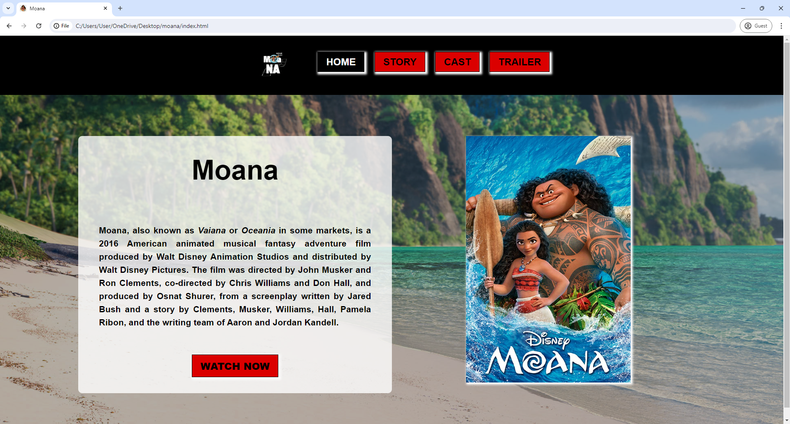

The HOME page process is;

* Create a web template using div tag with 1 main box / container, 2 line / row and 2 side / column.
* Create a background image in body tag using.

body{

    font-family: Arial, Helvetica, sans-serif;

    background-image: url('images/bg.jpeg');

    background-repeat: no-repeat;

  background-size: cover;  
 margin: 0;  
 padding: 0;

}

* Create logo section and navigation bar using div tag.

<div class="line1">

   <div class="logo">

      <img src="images/logo.jpg" alt="" style="width: 100px; height: auto; margin-right: 50px;">

  </div>

  <div class="nav">

      <a href="" class="active">HOME</a>

      <a href="story.html" class="btn_a">STORY</a>

      <a href="cast.html" class="btn_a">CAST</a>

      <a href="trailer.html" class="btn_a">TRAILER</a>

  </div>

</div>

* Insert poster image, description and link to outside site.

<img src="images/image1.jpeg" alt="" style="width:auto; height:600px; box-shadow: 3px 3px 5px 2px white;">

* Button “Watch Now” is hyperlink to Wikipedia site.

<div class="box1" style="margin-bottom: 50px;">

<a href="https://www.rottentomatoes.com/m/moana_2016" class="btn_a" target="_blank">WATCH NOW</a>

</div>

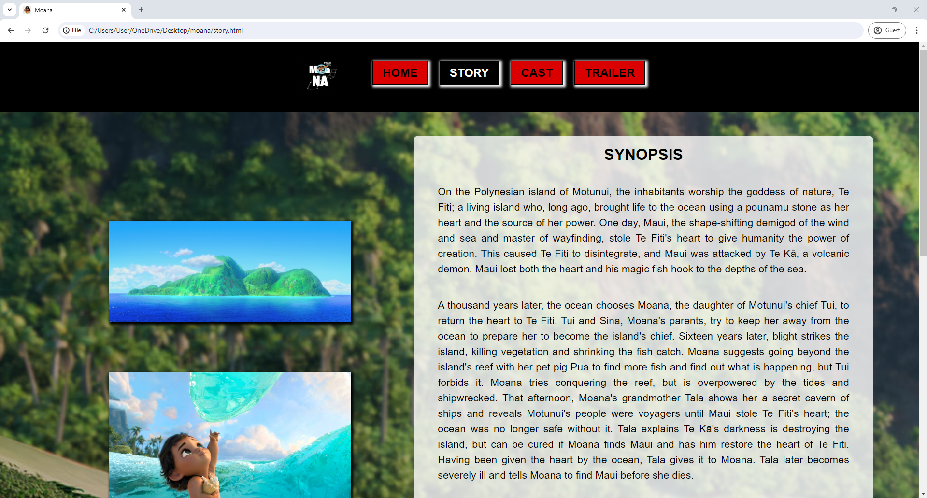

The STORY page process is;

* Using HOME page template which are div tag with 1 main-box class, 2-line classes, and 2 side classes.
* Using same background image.
* On the left side consists of 4 images.

<div class="side_3" style="align-items: center;">

   <div class="box3">

        <img src="images/image3.png" alt="" style="width:500px; height: fit-content; box-shadow: 3px 3px 5px 2px black;">

    </div>

    <div class="box3">

        <img src="images/image4.jpg" alt="" style="width:500px; height: fit-content; box-shadow: 3px 3px 5px 2px black;">

    </div>

    <div class="box3">

        <img src="images/image2.jpg" alt="" style="width:500px; height: fit-content; box-shadow: 3px 3px 5px 2px black;">

    </div>

    <div class="box3">

        <img src="images/image5.jpeg" alt="" style="width:500px; height: fit-content; box-shadow: 3px 3px 5px 2px black;">

     </div>

 </div>

* On the right side contain synopsis of the movie using h1 and p tag.

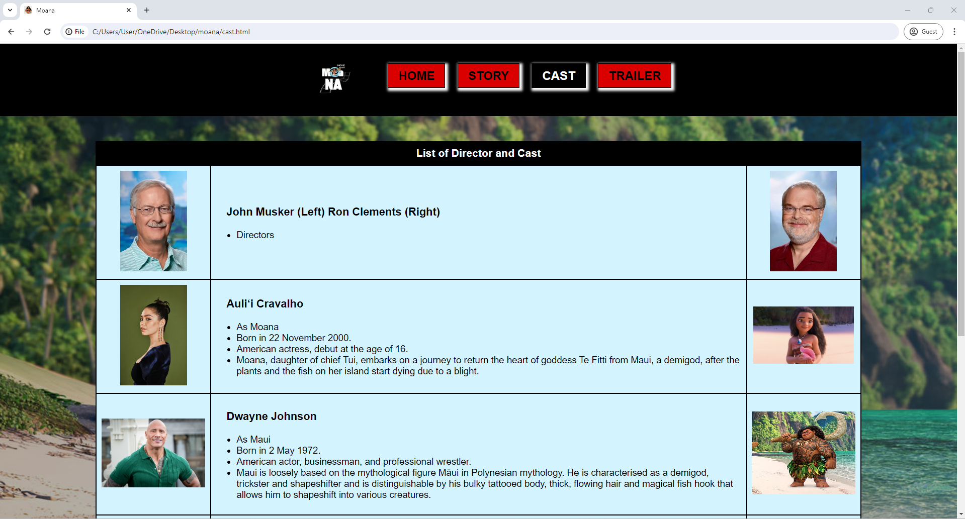

The CAST page process is;

* Using HOME page template which are div tag with 1 main-box class, 1-line class, and 1 box class at the center.
* Inside the cost_box class contain table list of director and cast.
* This table consists of 3 columns on each row.
* On the left side and right side of the column are contain hyperlink images.
* On the middle column contain the details of the cast or director using <ul> <li> tag.

<tr>

  <td style="text-align: center;">

      <a href="https://en.wikipedia.org/wiki/Auli%CA%BBi_Cravalho" target="_blank">

        <img src="images/cast_1.jpg" alt="" style="width: auto; height: 200px;">

      </a></td>

  <td>

      <h3 style="margin-left: 20px; margin-right: 20px;">Auliʻi Cravalho</h3>

      <ul>

        <li>As Moana</li>

        <li>Born in 22 November 2000.</li>

        <li>American actress, debut at the age of 16.</li>

        <li>Moana, daughter of chief Tui, embarks on a journey to return the heart of goddess Te Fitti from Maui, a demigod, after the plants and the fish on her island start dying due to a blight.</li>

      </ul></td>

  <td style="text-align: center;">

      <a href="https://en.wikipedia.org/wiki/Auli%CA%BBi_Cravalho" target="_blank">

        <img src="images/char_1.png" alt="" style="width: 200px; height: auto;">

      </a></td>

</tr>

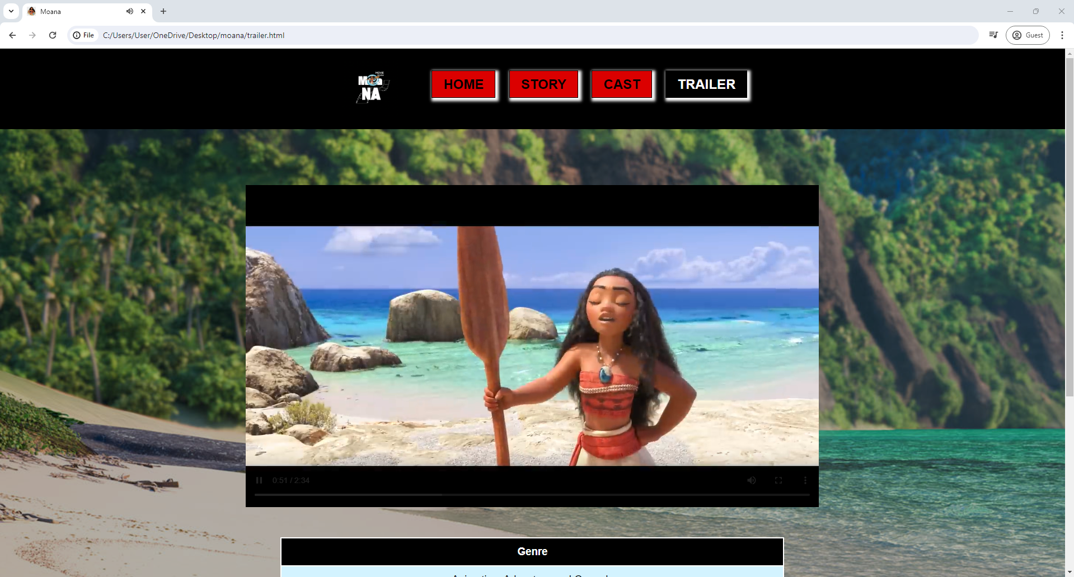

The TRAILER page process is;

* Using HOME page template which are div tag with 1 main-box class, 1-line class, and 2 box class at the center.
* In the top box contain offline trailer video using video tag.

<div class="box4">

   <video src="images/video.mp4" width="80%" height="auto" controls>

                        Your browser does not support the video tag.

   </video>

</div>

* At the bottom box contain table about movie detail attributes like genre, runtime, language and rating.

<table class="table1" cellpadding="0" cellspacing="0">

    <tr><th>Genre</th></tr>

    <tr><td>Animation, Adventure and Comedy</td></tr>

    <tr><th>Run Time</th></tr>

    <tr><td>107 Minutes</td></tr>

    <tr><th>Language</th></tr>

    <tr><td>English</td></tr>

    <tr><th>Rating</th></tr>

    <tr><td>7.6/10 IMDb & 89% Rotten Tomatoes</td>tr>

</table>